In Memoriam : Sharanya Jayawickrama
By Chantal Zabus, Editor-in-Chief, Postcolonial Text

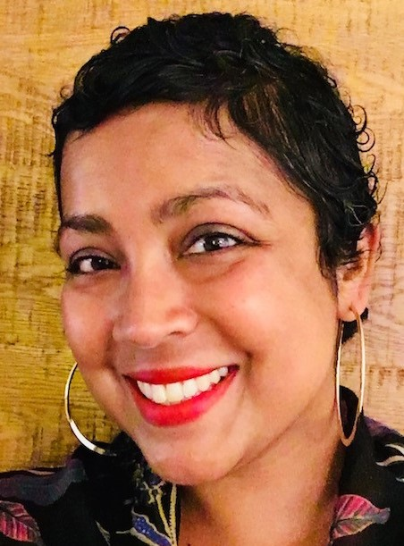

I am writing about Sharanya in these uncertain times when the unruly Covid-19 pandemic is looming large over our lives and some of us are “confined” while continuing to work online. While taking stock of the new vocabulary like “social distancing,” some of us are taking advantage of the diminishing lack of human contact to tackle unfinished business and to be more backward-looking. And this unprecedented crisis helps me reminisce about Sharanya who prematurely passed away on 9 September 2019.
Sharanya was devastatingly beautiful and kind. The picture above is dated 5 December 2018; Sharanya no longer had her beautiful long hair but it was still jet-black. The last time I skyped with her she was wearing a wig. I was still full of hope for her recovery when she and her family moved from Hong Kong, where they had been living since 2012, to Ireland, which was her husband Barry Crosbie’s home country. She received the best of care in an Oncology Centre in Dublin, two hours from her new home; in her last email to me she was still hoping to recover “some quality of life.” Her father, Dr. Niyal Jayawickrama, reported that her health unfortunately had begun to deteriorate in August 2019: “My elder daughter Nishana (who lives in London) and I visited her in hospital in Dublin on September 7th, and was with her when she passed away, quite unexpectedly, on the 9th after being active and positive even on the last day of her life.”
A memorial service was held in Rosslare, in County Wexford, her new home, and her cremation took place in Dublin on 14 September 2019. From what I gathered from another source, a lot of people flocked for the event from different parts of Ireland and from as far afield as Hong Kong, the United States and the UK. On behalf of Postcolonial Text, I passed on our condolences to her husband, Barry Crosbie, and to their children, Kaishori and Alokhi, her sister Nishana, and her parents-in-law Derek and Sheila Crosbie. Our colleague, Prof. Ranjan Goonetilleke, has also passed on our deepest sympathies to her father.
I was in Madagascar on a research fieldtrip when I was hit by the news of Sharanya’s death. I was travelling alone and could not very well tell some of the people at the Maison Lovasoa in Antananarivo that the Associate Editor of Postcolonial Text had passed away. I however felt connected to the Postcolonial Text community, most of us academics who are familiar with the running of a Journal, or simply with team work.
Sharanya and myself were a Team; she was the good cop; I was the bad cop. And you needed that balance of both roles to keep the Journal afloat. With her customarily quiet efficiency, her erudition, her generosity, her kindness, she always went beyond the call of duty to help anguished authors and her peers on the Team. Esther De Bruijn, in her former capacity as LayOut Editor, Sharanya, and myself would relish those shared moments of trepidation just before the finish line, when we would “press the button” and a new issue would come out!
After the phase of grief and bereavement, it then dawned on me that I had lost not only a precious cog in the at times not-so-intuitive PT system but also a friend. Sharanya had been with the Journal since its inception in 2004 and had acted in various capacities until she was nominated Associate Editor in 2013. Sharanya-the- missing-cog is still missing in the sense that we still occasionally mismanoeuver but through trials and errors, we now have a relative mastery of the system. In the meantime, Esther became Managing Editor and Rachel Gregory Fox became LayOut Editor and they helped me publish the second, much delayed issue of the 14th volume of Postcolonial Text in October 2019, a month after Sharanya’s decease. And later Alessandra Capperdoni, one of our Book Reviews Editors, also agreed to become Assistant Editor and recently Souhir Zekri joined the Team as the new LayOut Editor.
The dismembered Team is now reconstituted but I still miss my friend, the one-who-would-always-give-a-second-chance friend. Sharanya would use humor to handle irritating matters, like authors forgetting to hit “Complete” and inadvertently stalling the automated process. When an author would inordinately complain, after we had tried so hard to accommodate their needs, Sharanya would say: “My eyes are rolling.” And even though we were about 6 000 miles apart (me in Paris; her in Hong Kong), I could actually “see” her beautiful round eyes roll around in a circle, not in annoyance or impatience but in detached amusement.
Sharanya also gave her own husband a second chance when they first met as PhD students in Cambridge in 2000—she was studying English literature and he was studying History. Here is the anecdote Barry shared during his Eulogy: “I remember the first time I saw Sharanya in Darwin College in Cambridge. It was a Thursday night at a special weekly event they held there called “bops” – I remember thinking that she was the most beautiful thing that I had ever seen. She had lovely long black hair, gorgeous brown skin that glowed like burning embers on a fire, and a smile that always beamed from ear to ear. After a couple of drinks, I summoned up the courage to approach her to say hi and, much to my amazement, she actually stayed and chatted to me for hours … – You see back in 2000 I was a bit of a dork and in order to act cooler than I was I used to go out without my glasses on quite a lot – these were the days before I discovered contact lens. … I remember the second night I met Sharanya – a sort of ‘unofficial date,’ we were supposed to meet again in the bar at Darwin College. And of course, me being very vain back then, turned up without my glasses on and I spent the whole night walking around blindly trying to find her without success. It was only the next morning when Sharanya phoned me quite annoyed that I realized that I had actually walked by her several times with, what she described as a mysterious blank expression on my face, and that she was only calling me because apparently I had been nice when we met the week before and that she was keen to give me a second chance.” This anecdote encapsulates Sharanya’s character and essence.
This anecdote also leaves me smiling and even chuckling, because that is how we both were—chuckling and laughing in cyberspace— and our laughters would echo down the labyrinthine pathways on the PT site and shake the august algorithms that ruled both our lives in our relationship to Postcolonial Text. May our new Team be blessed with Sharanya’s contagious joy!

